**Approver Historical View and Charts**

**(Mobile)**

**Enhancement**

Contents

1. Existing Flow: 3

2. Proposed Flow: 4

# Existing Flow:

* Currently, when Claimant from the Charts page clicks on Filter button (**Screen** **1**), then in the Filter page where Claimant can see two options to filter (**Screen 2**) with Duration (From and To Calendar pickers)

1. Expense Categories
2. Expense Status

Screen

Screen

* When Claimant clicks on Expense Categories option then he/she is navigated to Select Category page **(Screen 3**).
* In the Select Category page (**Screen 3**), Claimant unselects the category(s) for which expenses were created and displayed in the Charts (**Screen 1**). Click on Ok button.

Screen

* Claimant is navigated to Filter page again (**Screen 2**)
* From, Filter page (**Screen 2**), when Claimant clicks on Ok button, Claimant is redirected to Charts Page (**Screen 4**) wherein claimant can see Clear Filter button and Filter Applied label with the filter applied in the Chart.

Screen

* When Claimant clicks on Expense Status option then he/she is navigated to Expense Status page (**Screen 5**)
* In the Expense Status page (**Screen 5**), Claimant unselects or selects the sub options of Claim, Approve and Reimburse and click on Ok button.
* Claimant is navigated to Filter page again (**Screen 2**)
* From, Filter page (**Screen 2**), when Claimant clicks on Ok button, Claimant is redirected to Charts Page (**Screen 6**) wherein claimant can see Clear Filter button and Filter Applied label label with the filter applied in the Chart.

Screen

Screen

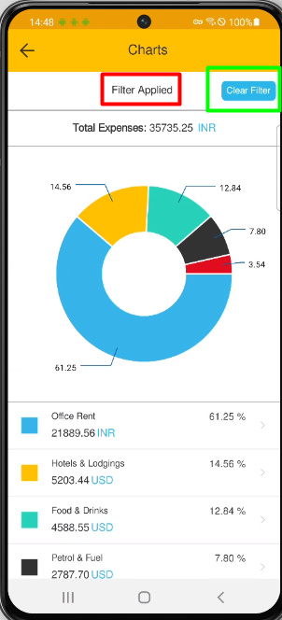

* In the Expense Status page **(Screen 7**), Claimant unselects all the sub options of Claim, Approve and Reimburse and click on Ok button.
* Claimant is navigated to Filter page again (**Screen 2**)
* From, Filter page (**Screen 2**), when Claimant clicks on Ok button, Claimant is redirected to Charts Page (**Screen 8**) where still chart with Expense Category count can be seen

Screen

Screen

# Proposed Flow:

* After Applying the filter, Claimant should be redirected to Chart page (**Screen 9**) instead of Filter page

Screen

* There should be option to go back to Filter applied page so that claimant can do modification in his existing applied filter (**Screen 10**)

Screen

* When in the Expense Status page Claimant unselects all the sub options of Claim, Approve and Reimburse and click on Ok button then in the Chart page Chart should be greyed out and nothing should be displayed where Expense Categories with their name, colour code and percentage is displayed. **(Screen 11**)

Screen